Chapter 1
Roughly nine out of 10 say supplier and material costs will increase significantly in the year ahead (Análise do ano de 2025)
Artificial intelligence (AI) could be part of the solution. AI can accelerate the speed of insights, decision-making and organizational change. We’re also beginning to see how AI agents can fundamentally transform work and change how businesses operate. For instance, AI agents can be coordinated across demand forecasting, procurement and logistics tracking to address potential supply chain bottlenecks and reduce delays.
What it means for you: Focus on being efficient in the near term but do it in a way that allows your company to be flexible and ready for future challenges. Explore how to apply AI in different ways — from driving efficiencies today to anticipating and evaluating scenarios to better configure for tomorrow.

Chapter 2
Advanced capabilities like digital twins and data ecosystems lag far behind in adoption but could be a missed opportunity.
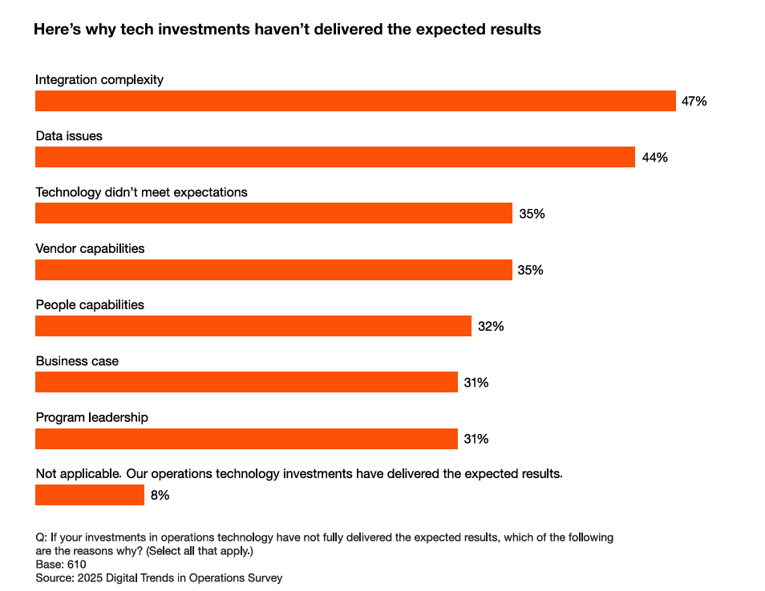
Alarmingly, one of the least selected reasons is the business case for tech investment — unclear objectives, weak rationale or difficulty understanding costs — which may suggest a blind spot for many companies.

Chapter 3
Chapter 4
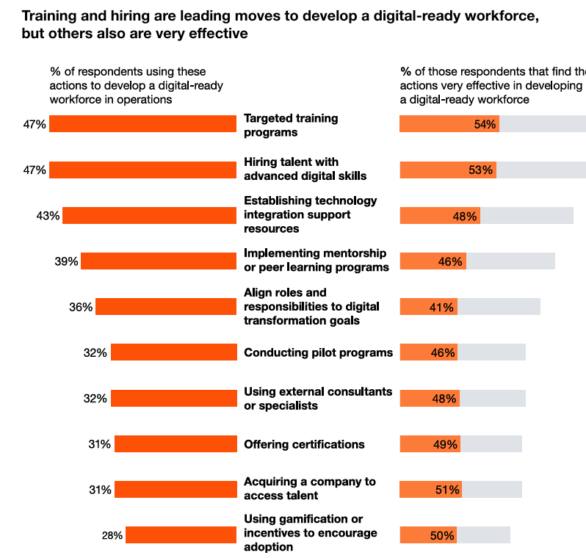
Chapter 5
Integration with existing systems — ranked among the top three challenges by 42% of respondents — and data issues (37%), such as availability and quality, are most common. This aligns with our experience as we often see companies overlook the complexity in developing new AI capabilities — all of which require solid integration and data to power high ROI solutions

